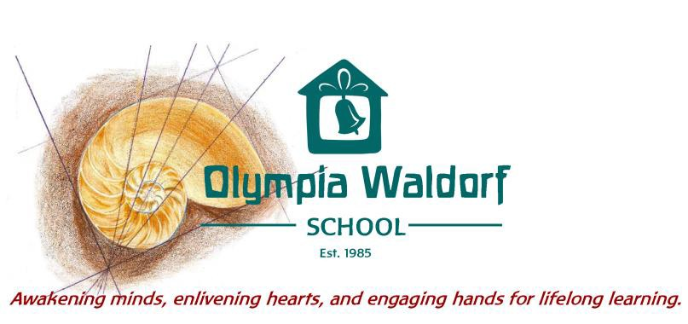
Job Opening: Specialty Teacher
For school year 2018-19

Olympia Waldorf School is seeking an experienced teacher with strong interpersonal, communication skills, effective classroom management, and passion for teaching and learning. It is our desire to hire a qualified individual to teach a specialty they are enthusiastic about. Possible specialties include, but are not limited to: movement, foreign language, handwork, or middle-school skills (ie: language arts or math).

Olympia Waldorf School serves approximately 150 students from preschool through eighth grade. Our faculty is currently comprised of three early childhood teachers, eight grades teachers, and four specialty teachers. We have graduated thirteen classes from Grade 8. A full administrative staff manages the daily activities of the organization. Olympia Waldorf School is fully accredited by the Association of Waldorf Schools of North America (AWSNA).

Essential Functions: Teach classes to grades 1-8, depending on area of expertise. The teacher will prepare lessons, teach and manage a class of up to 22 students at a time. Teachers also participate in regular meetings centered on pedagogy and grade school needs.

Minimum Qualifications: All candidates must have a bachelor's degree, familiarity with the Waldorf method, and at least two years teaching experience.

Preferred Qualifications: Five years teaching experience and Waldorf Teaching Certificate

Compensation: Olympia Waldorf School has committed to competitive wages for employees. Our faculty compensation package includes increments for teacher experience, teaching certificate and master's degree. Benefits include partial tuition remission, medical, dental, and vision benefits, 403B option, and professional development opportunities as needed.

Hiring Process: Qualified candidates will be invited by our Head of School to schedule a hiring visit in April.

How to Apply: Interested candidates are asked to submit a resume, three professional references (at least two who served in a supervisory capacity), and a cover letter describing their education experience and why they want to work for Olympia Waldorf School via email to dkehoe@olympiawaldorf.org or by mail to Olympia Waldorf School Hiring Committee, P.O. Box 130, East Olympia, WA, 98540. For more information, contact our Head of School, Dominic Kehoe, at 360-493-0906. We encourage you to visit our website to learn more about our school at www.olympiawaldorf.org.
OWS is an Equal Opportunity Employer and maintains a strict policy prohibiting all forms of unlawful discrimination based on race, religion, national origin, ancestry, citizenship, pregnancy, physical or mental disability, marital status, sexual orientation, gender identification, color, age, or any other characteristic protected by applicable local, state or federal law in its hiring and employment practices.

